Filed by DFP Healthcare Acquisitions Corp.

Pursuant to Rule 425 under the Securities Act of 1933

and deemed filed pursuant to Rule 14a-12

under the Securities Exchange Act of 1934

Subject Company: DFP Healthcare Acquisitions Corp.

Commission File No. 001-39248

Date: October 12, 2021

This filing relates to the proposed merger involving DFP Healthcare Acquisitions Corp (“DFP”) with TOI Parent, Inc. (“TOI”), pursuant to the terms of that certain Agreement and Plan of Merger, dated as of June 28, 2021.

The following is an analyst presentation, which will be made available on October 12, 2021.


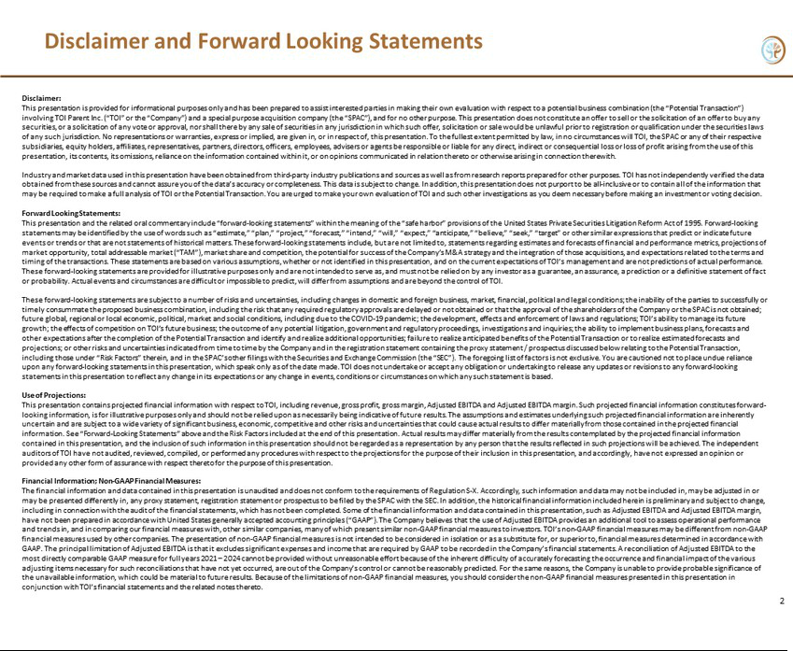



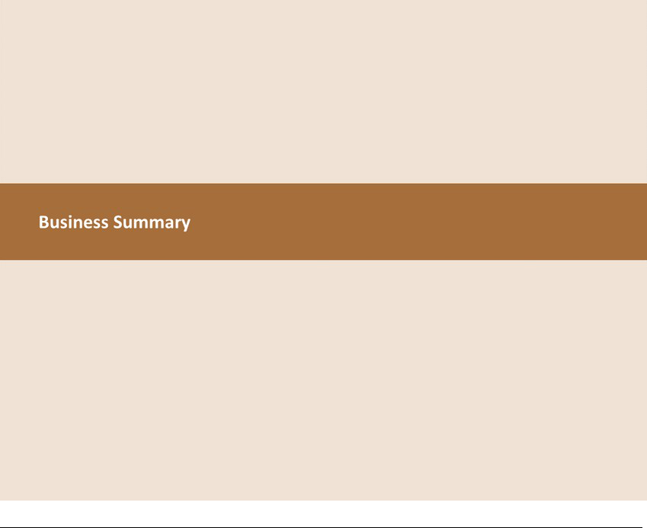

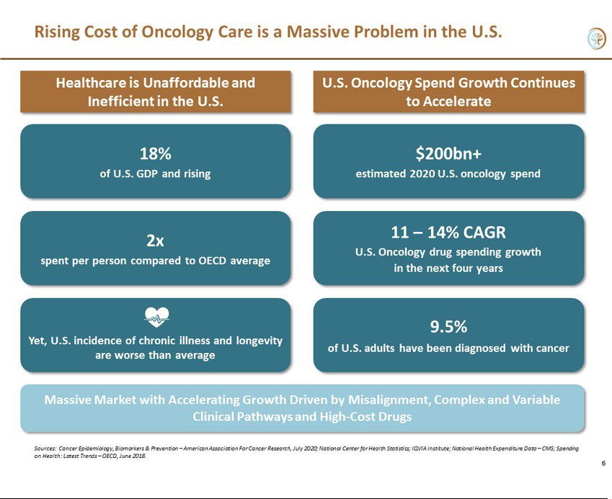

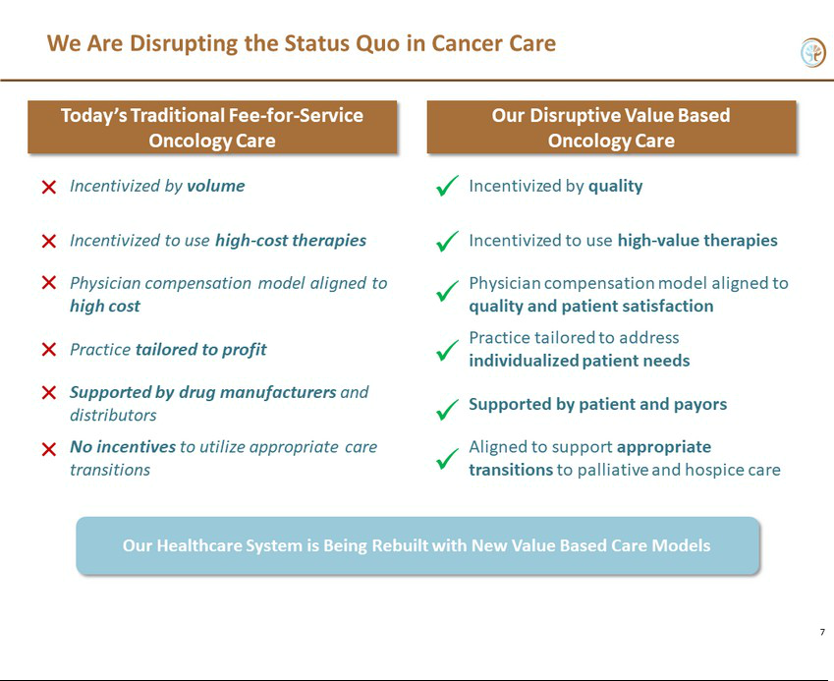

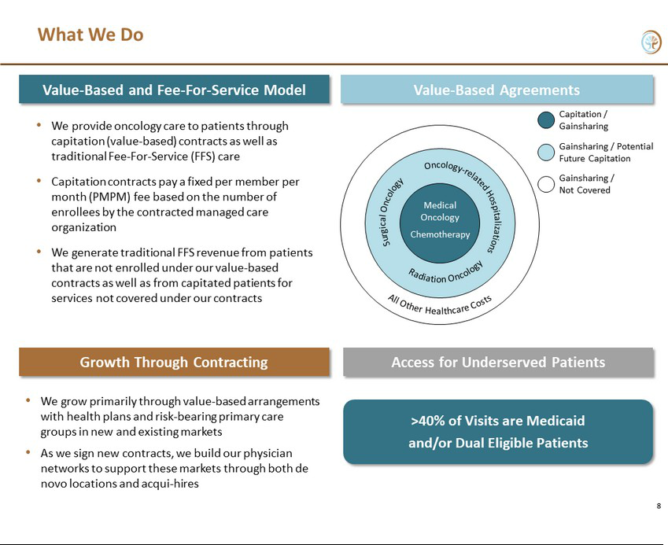

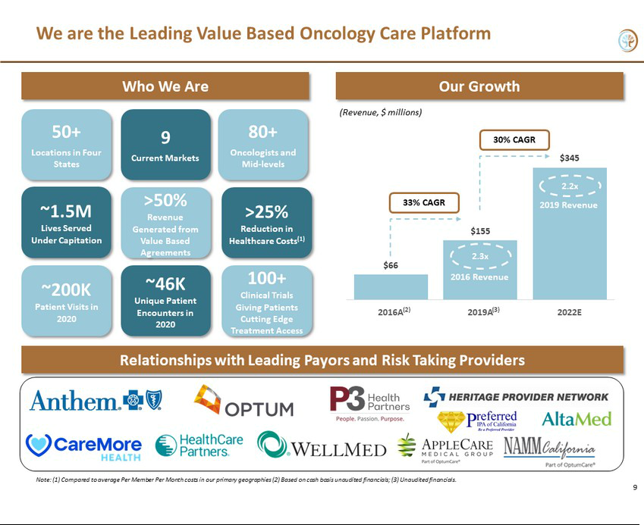

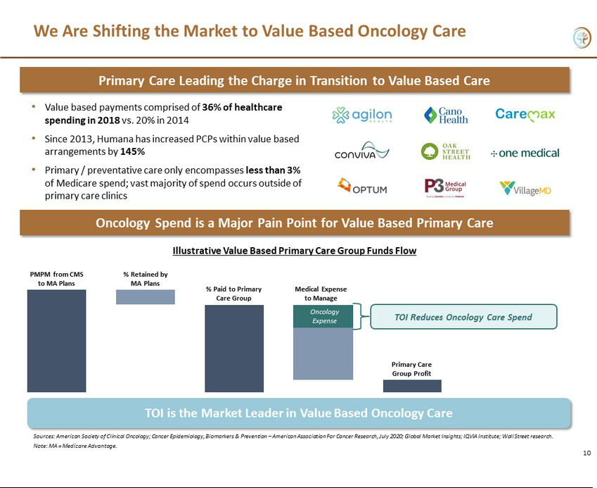



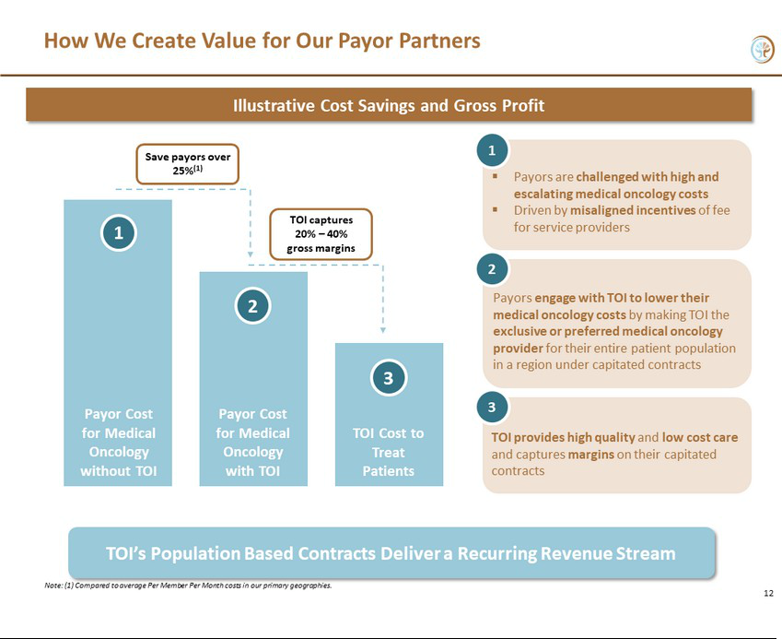

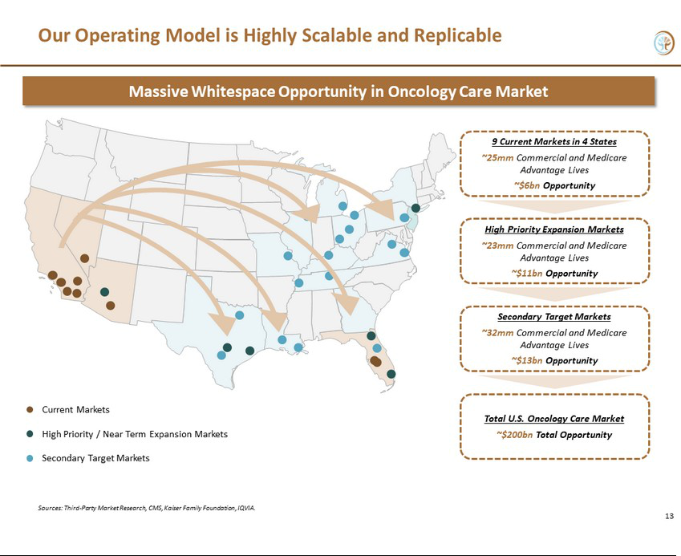

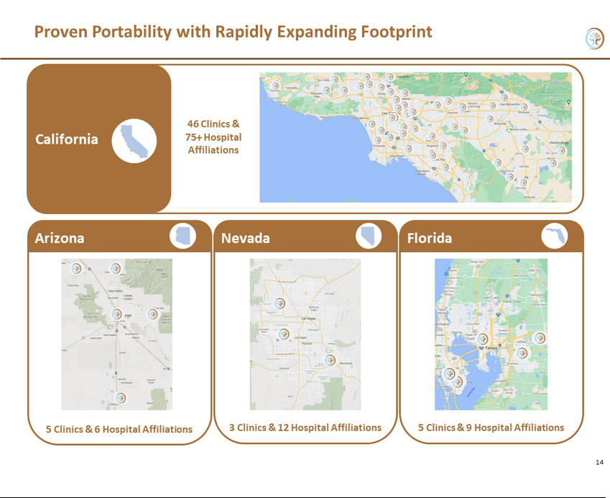





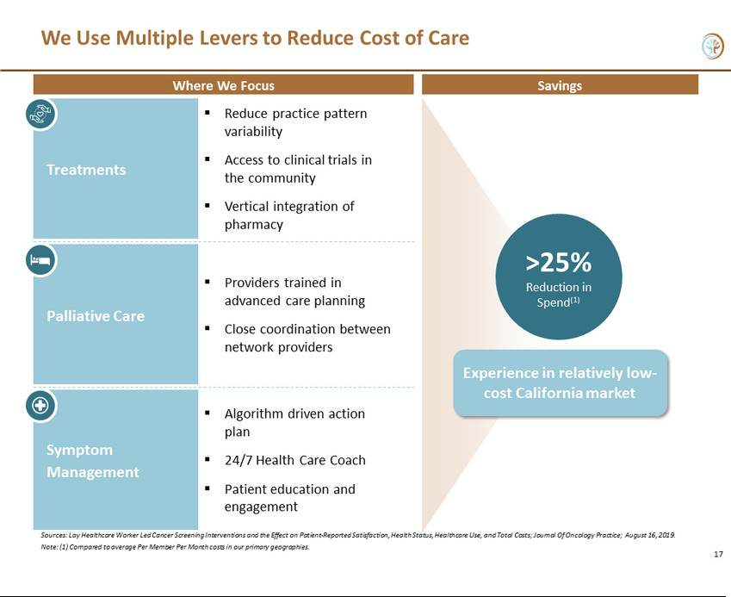

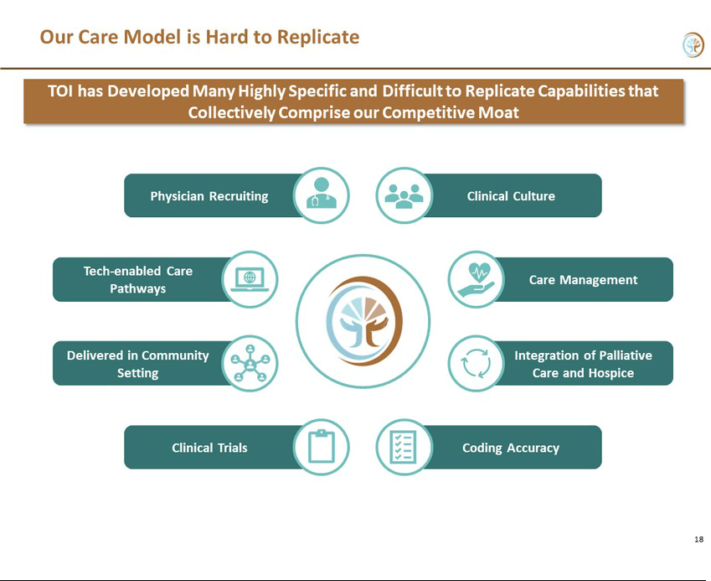

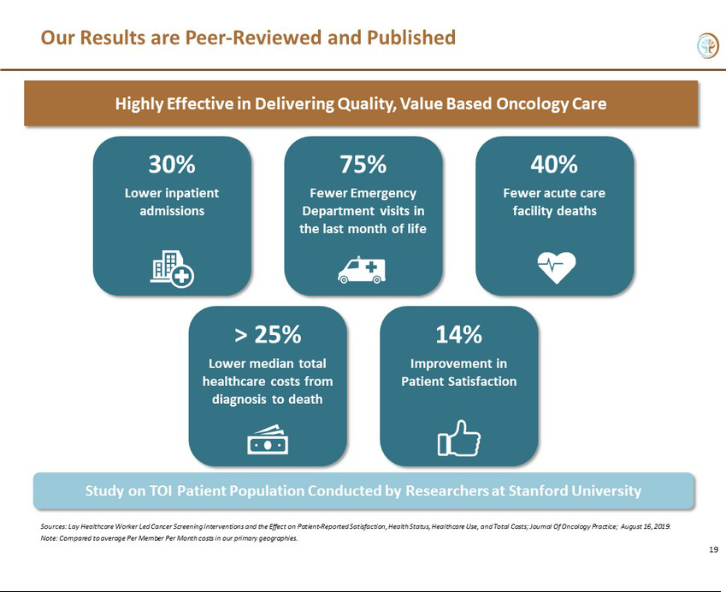

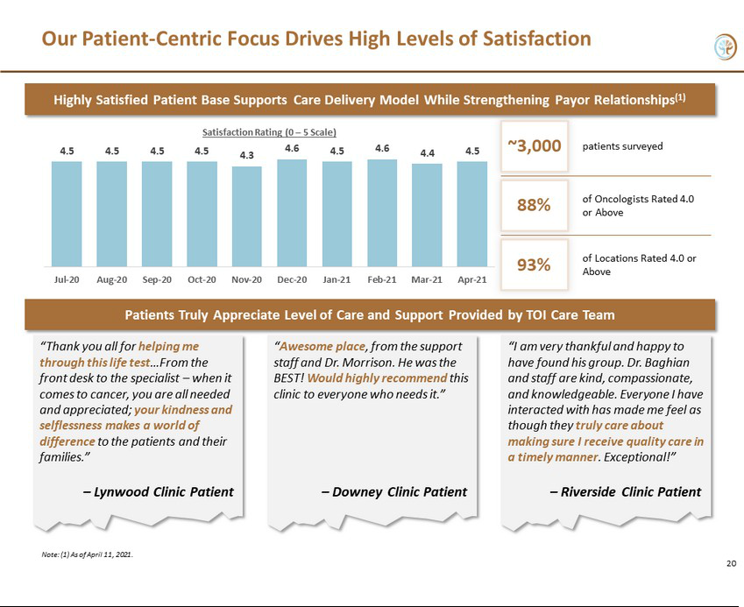

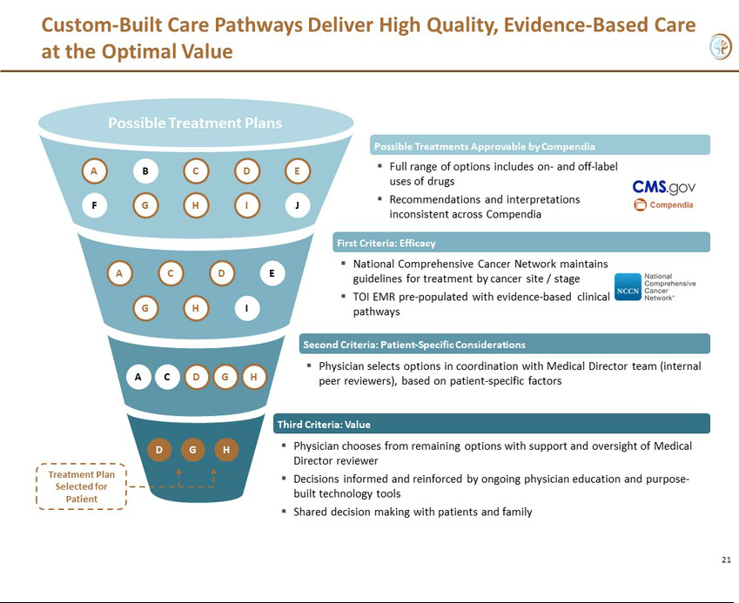

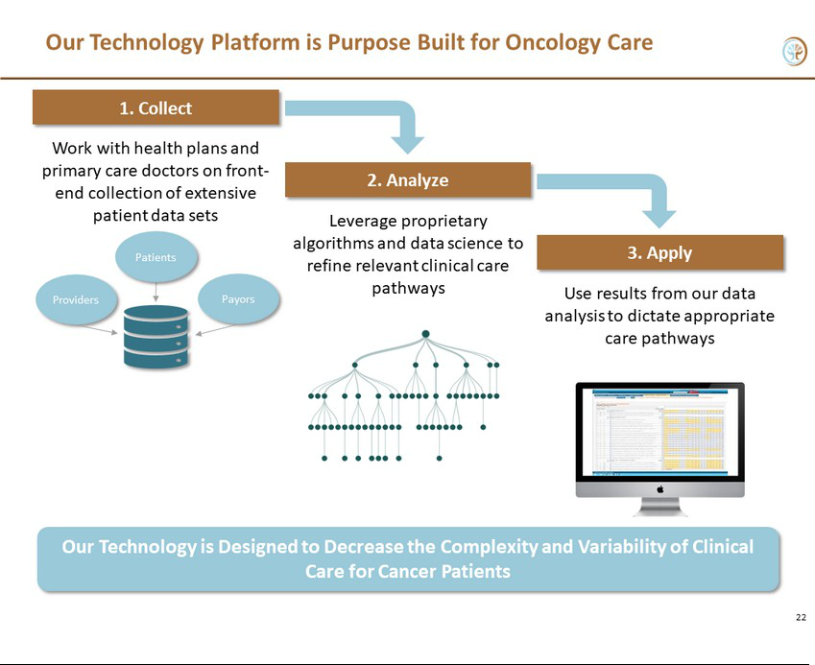

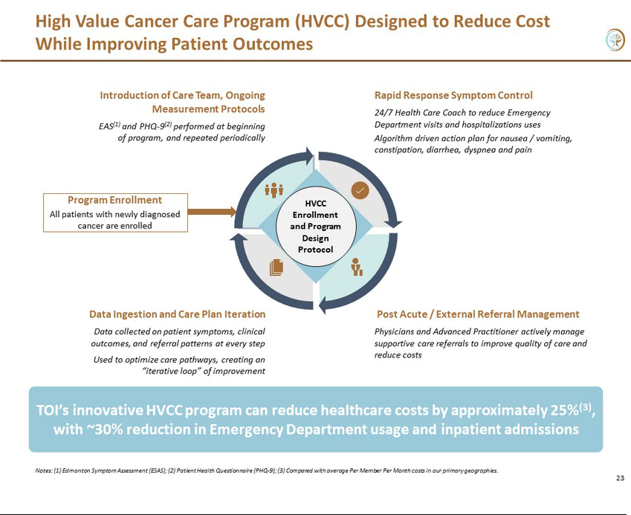



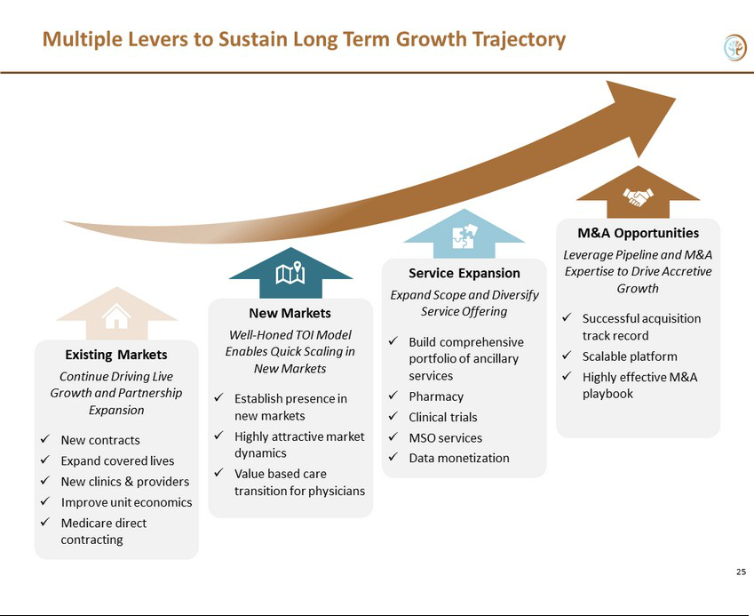

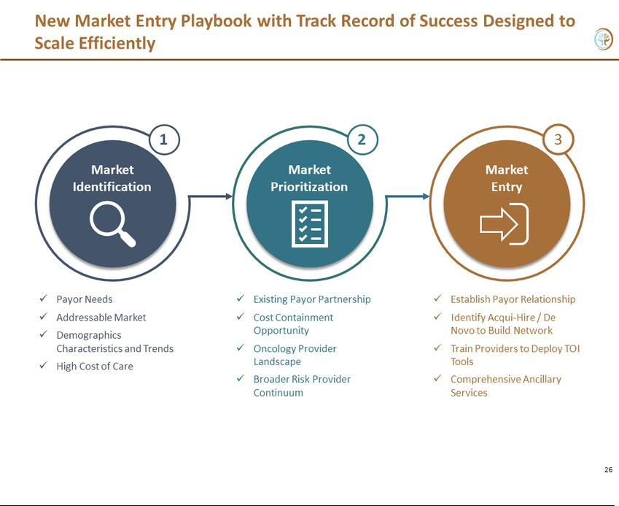

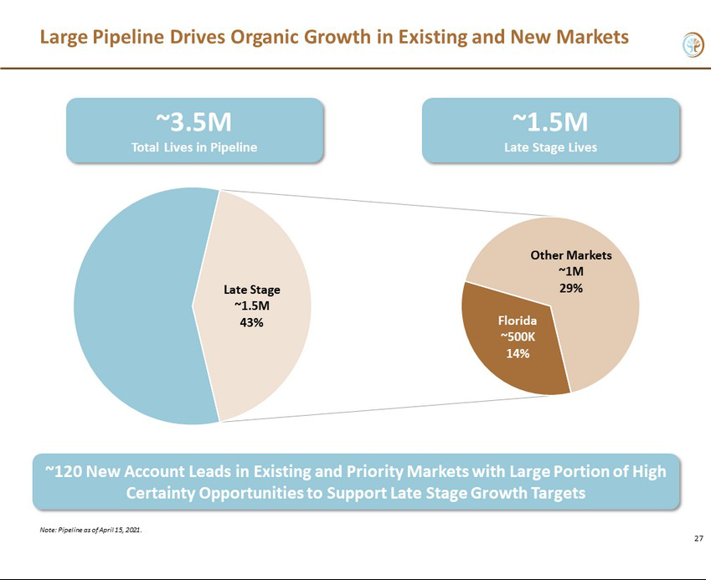

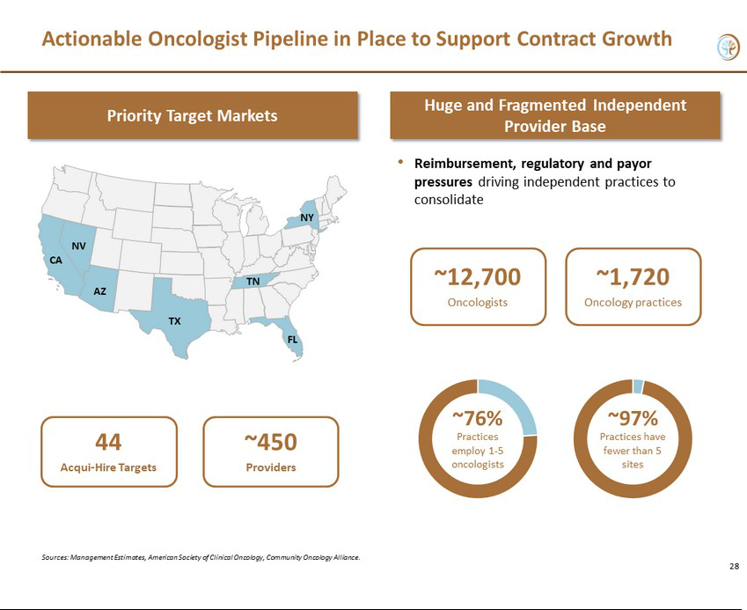

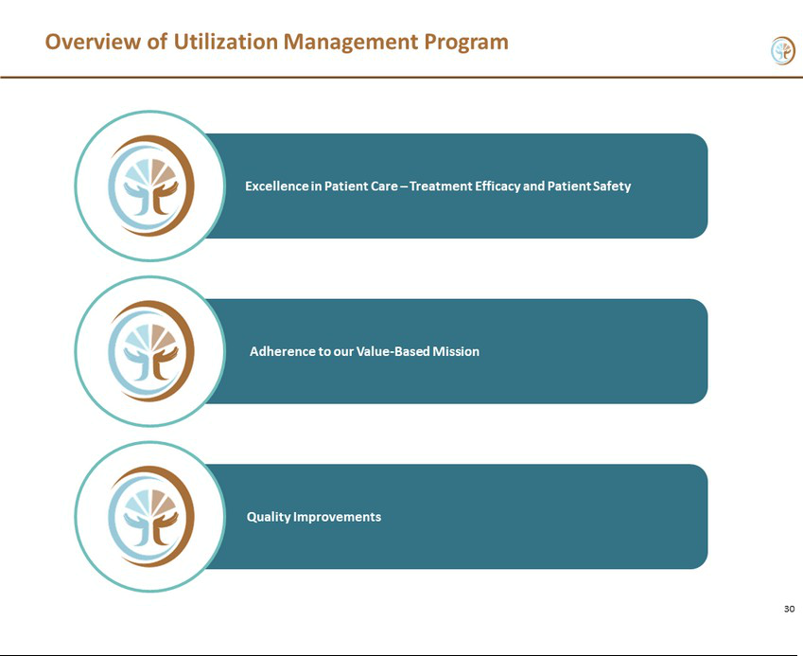

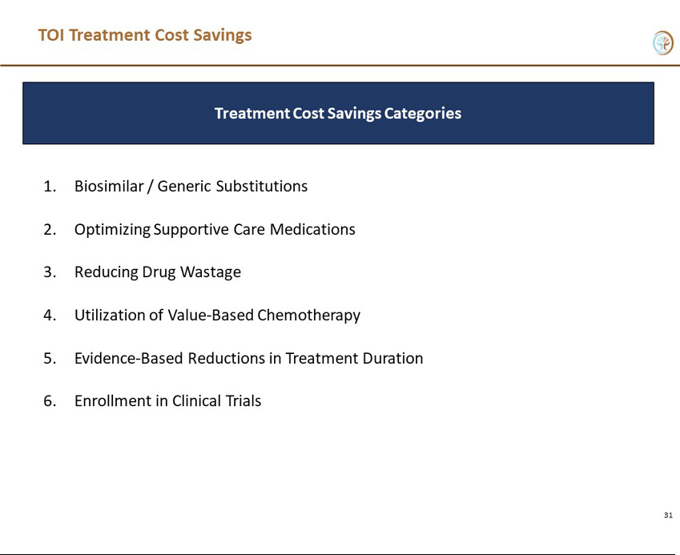



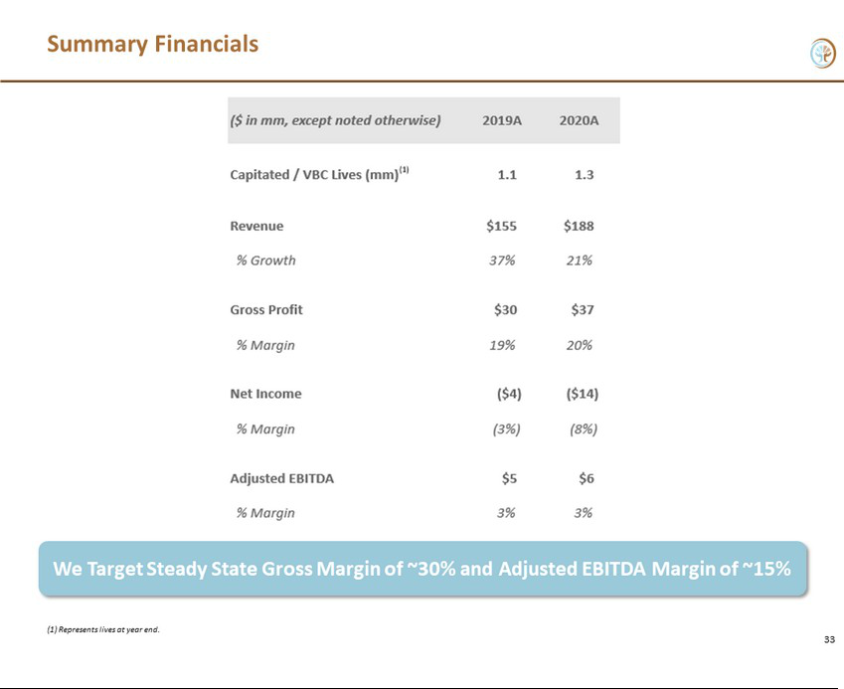

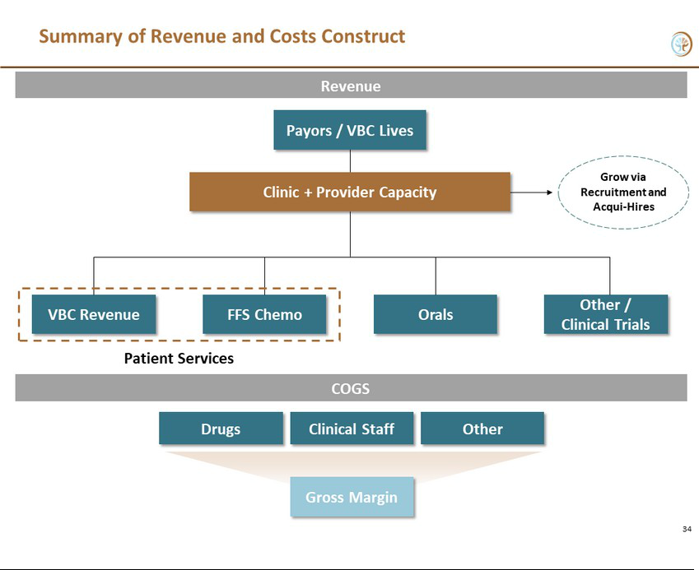

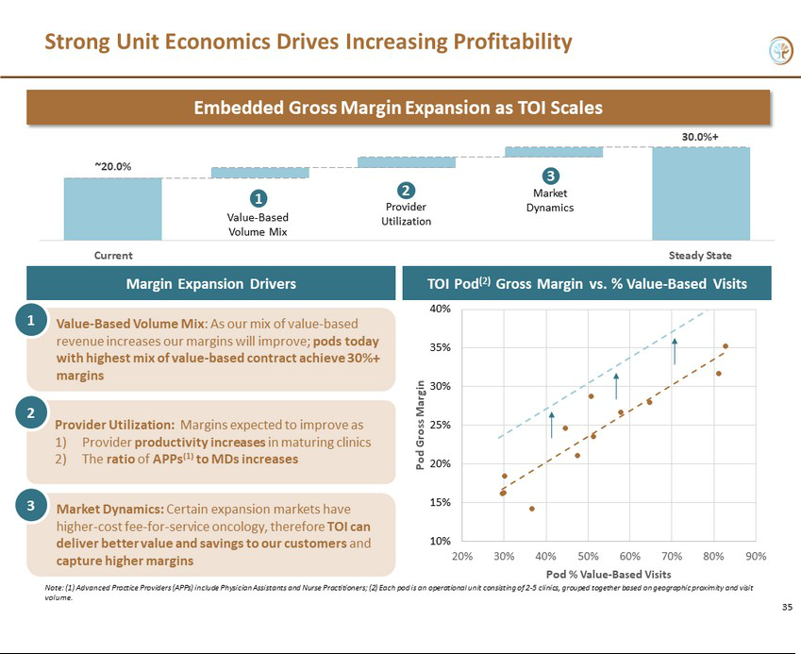

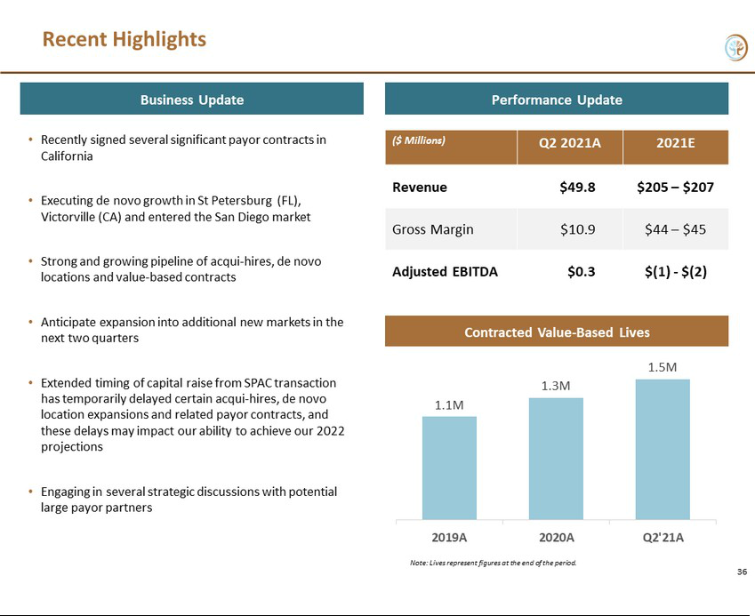



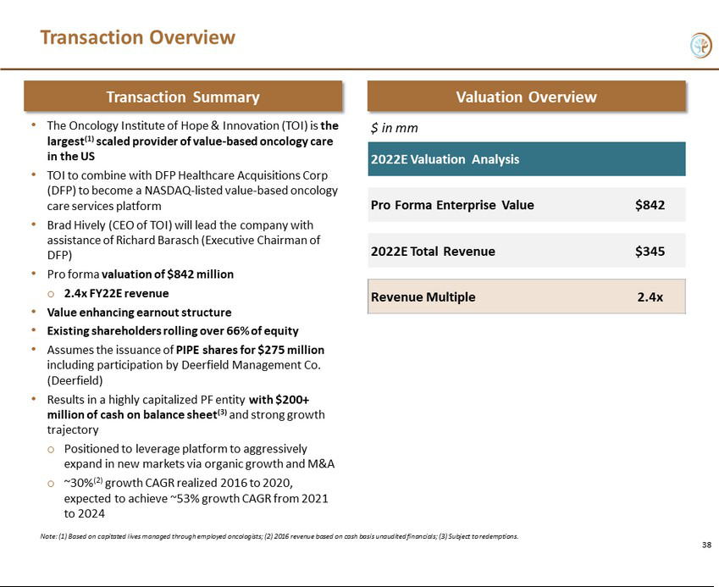

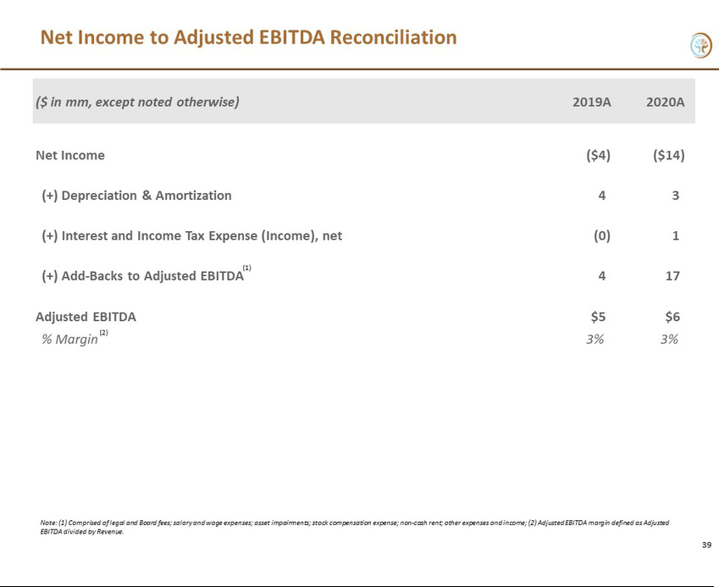

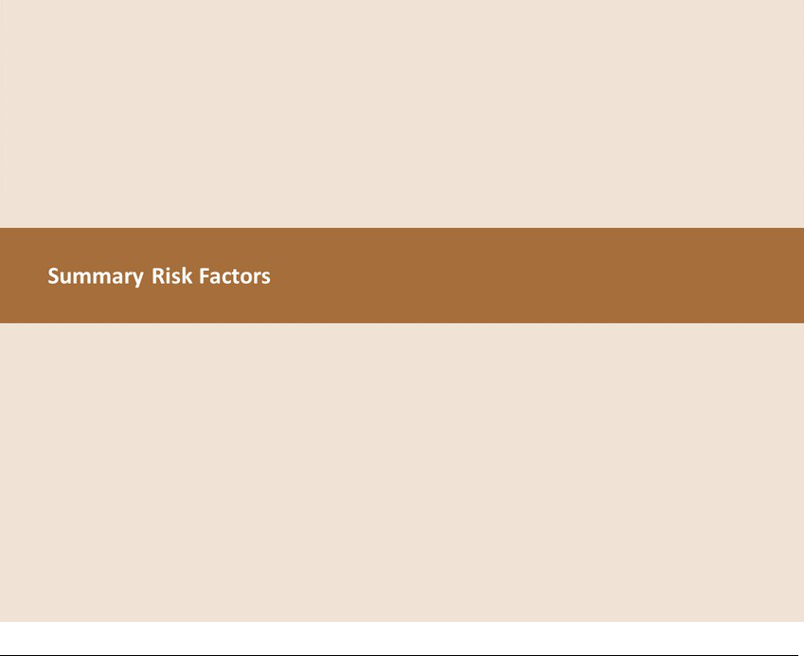

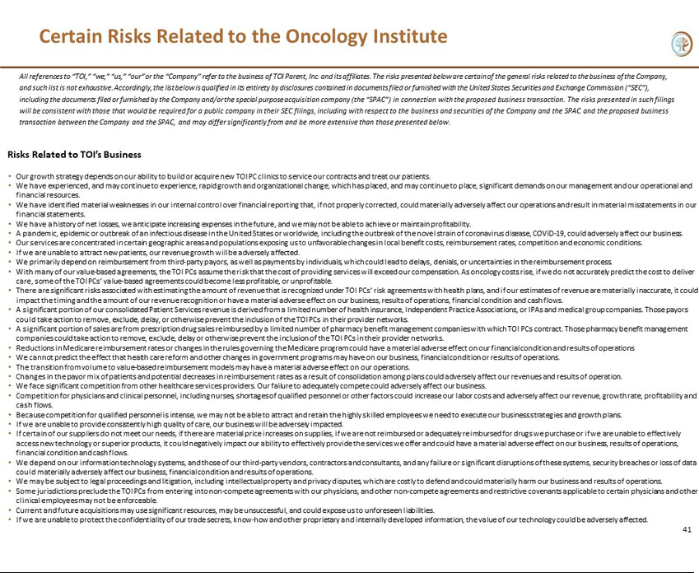

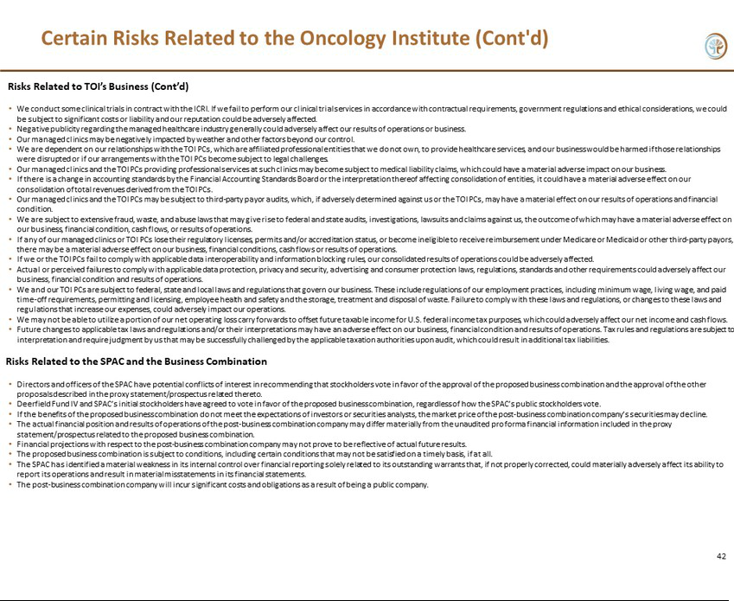

Important Information and Where to Find It

In connection with the proposed business combination, DFP intends to file a registration with the statement on Form S-4 (the “Registration Statement”) with the SEC, which includes a proxy statement/prospectus and certain other related documents, which will be both the proxy statement to be distributed to holders of shares of DFP common stock in connection with DFP’s solicitation of proxies for the vote by DFP’s stockholders with respect to the business combination and other matters as may be described in the definitive proxy statement, as well as the prospectus relating to the offer and sale of securities of DFP to be issued in the business combination. DFP’s stockholders and other interested persons are advised to read the preliminary proxy statement/prospectus and documents incorporated by reference therein filed in connection with the business combination, as these materials will contain important information about the parties to the business combination agreement, DFP and the business companion. After the Registration Statement is declared effective, the definitive proxy statement will be mailed to DFP’s stockholders as of the record date to be established for voting on the business combination and other matters as may be described in the Registration Statement. Stockholders will also be able to obtain copies of the proxy statement/prospectus and other documents filed with the SEC that will be incorporated by reference in the proxy statement/prospectus, without charge, once available, at the SEC’s web site at http://www.sec.gov, or by directing a request to: DFP Healthcare Acquisitions Corp. at its principal executive offices 345 Park Avenue South, New York, NY 10010.

Participants in the Solicitation

DFP and its directors and executive officers may be deemed participants in the solicitation of proxies from DFP’s stockholders with respect to the proposed business combination. A list of the names of those directors and executive officers and a description of their interests in DFP is contained in the registration statement on Form S-1, which was initially filed by DFP with the SEC on February 21, 2020 and is available free of charge at the SEC’s web site at www.sec.gov, or by directing a request to DFP Healthcare Acquisitions Corp. at its principal executive offices 345 Park Avenue South New York, New York 10010. Additional information regarding the interests of such participants is contained in the Registration Statement.

TOI’s directors and executive officers may also be deemed to be participants in the solicitation of proxies from the stockholders of DFP in connection with the business combination. A list of the names of such directors and executive officers and information regarding their interests in the business combination is included in the Registration Statement.

Forward-Looking Statements

This communication includes certain statements that are not historical facts but are forward-looking statements for purposes of the safe harbor provisions under the United States Private Securities Litigation Reform Act of 1995. Forward-looking statements generally are accompanied by words such as “believe,” “may,” “will,” “estimate,” “continue,” “anticipate,” “intend,” “expect,” “should,” “would,” “plan,” “predict,” “potential,” “seem,” “seek,” “future,” “outlook,” and similar expressions that predict or indicate future events or trends or that are not statements of historical matters. These forward-looking statements include, but are not limited to, statements regarding projections, estimates and forecasts of revenue and other financial and performance metrics and projections of market opportunity and expectations, the expectation that DFP’s common stock will continue to be listed on Nasdaq, and the anticipated closing date of the proposed business combination. These statements are based on various assumptions and on the current expectations of DFP and TOI and are not predictions of actual performance. These forward-looking statements are provided for illustrative purposes only and are not intended to serve as, and must not be relied on by any investor as, a guarantee, an assurance, a prediction or a definitive statement of fact or probability. Actual events and circumstances are difficult or impossible to predict and will differ from assumptions. Many actual events and circumstances are beyond the control of DFP and TOI. These forward-looking statements are subject to a number of risks and uncertainties, including the outcome of judicial and administrative proceedings to which DFP following the business combination (“The Oncology Institute”) may become a party or governmental investigations to which The Oncology Institute may become subject that could interrupt or limit The Oncology Institute’s operations, result in adverse judgments, settlements or fines and create negative publicity; changes in The Oncology Institute’s clients’ preferences, prospects and the competitive conditions prevailing in the healthcare sector; the inability of the parties to successfully or timely consummate the proposed business combination, including the risk that any required regulatory approvals are not obtained, are delayed or are subject to unanticipated conditions that could adversely affect the combined company or the expected benefits of the proposed business combination or that the approval of the stockholders of DFP and/or the equity holders of TOI for the proposed business combination is not obtained; failure to meet stock exchange listing standards following the consummation of the business combination; costs related to the business combination; failure to realize the anticipated benefits of the proposed business combination, including as a result of a delay in consummating the proposed business combination or a delay or difficulty in integrating the businesses of DFP and TOI; the amount of redemption requests made by DFP’s stockholders; the impact of COVID-19 on the combined company’s business and/or the ability of the parties to complete the proposed Business Combination; those factors discussed in the Registration Statement under the heading “Risk Factors,” and other documents of DFP filed, or to be filed, with the SEC. If the risks materialize or assumptions prove incorrect, actual results could differ materially from the results implied by these forward-looking statements. There may be additional risks that neither DFP nor TOI presently know or that DFP and TOI currently believe are immaterial that could also cause actual results to differ from those contained in the forward-looking statements. In addition, forward- looking statements reflect DFP’s and TOI’s expectations, plans or forecasts of future events and views as of the date of this press release. DFP and TOI anticipate that subsequent events and developments will cause DFP’s and TOI’s assessments to change. DFP and TOI do not undertake any obligation to update any of these forward- looking statements. These forward-looking statements should not be relied upon as representing DFP’s and TOI’s assessments as of any date subsequent to the date of this press release. Accordingly, undue reliance should not be placed upon the forward-looking statements.

Non-Solicitation

This communication is for informational purposes only and shall not constitute a solicitation of a proxy, consent or authorization with respect to any securities or in respect of the proposed business combination and shall not constitute an offer to sell or a solicitation of an offer to buy any securities, nor shall there be any sale of securities in any state or jurisdiction in which such offer, solicitation, or sale would be unlawful prior to registration or qualification under the securities laws of such state or jurisdiction. No offering of securities shall be made except by means of a prospectus meeting the requirements of Section 10 the Securities Act of 1933, or an exemption therefrom.

2

